WAPPO INDIANS
OF
NAPA
COUNTY

Wappo Indians of Napa County
Language

The Wappo Indians had no written language. They shared their ideas, stories, and feelings by speaking only. Stories and customs were passes down by parents to their children.
Their name has been spoken and written many way. Here are a few: Ashochimi, Caymus, Guapos, Mayacama, Mishewal, Rincon, Wapo, Wappa, and Wattos.

Place Names
City | Wappo Name | Meaning
Calistoga | Nilektsonoma | Chicken Hawk Place
Pacheteaus | Meywahlennoma | Water Coming Up Village
St. Helena | Anakotanoma | Bull Snake Village
Ritchey Creek | Kaliholmanok | Naked Woods People Friendly
Alexander Valley | Unutsawaholmanoma | Toyon Bush Berry Place
Geysers | Tekenantsonoma | Mineral Mouth Village
Mt. St. Helena | Kanamota | Human Mountain
Wappo Indians of Napa County
Games

Grass Game: A game for two or more players. One player holds a few small bones in his hand. He shuffles them back and forth, swaying and singing, trying to confuse the opponent. When he stops, his opponent guesses what hand the bones are in. The first player to score 12 points wins.
Shinny: Two teams of six players each. One player guards the goal. The other players kick a ball made of madrone root towards the other team's goal, which is up to a half mile away. There were no time outs or rest periods.
Stick Dice: A game for women played with a small bone from a deer knee. The bone is tossed like a die. Different amounts of points were earned when the bone landed on a particular side. 12 points would win the game.
Stick Guessing Game: Played with approximately 50 sticks. Opponents would try to guess how many over a multiple of 8 were in the holder's hand.

Wappo Indians of Napa County
Village Map
Wappo villages were built near rivers and creeks. The villages included one or two Sweat House, used for ceremonies and treating illnesses, and up to 40 shelters.
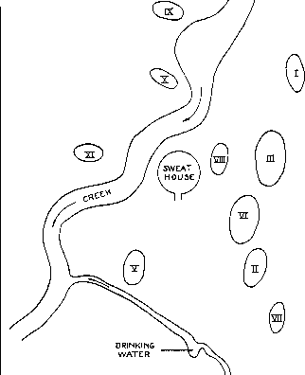

Wappo Indians of Napa County
Map of Wappo Villages
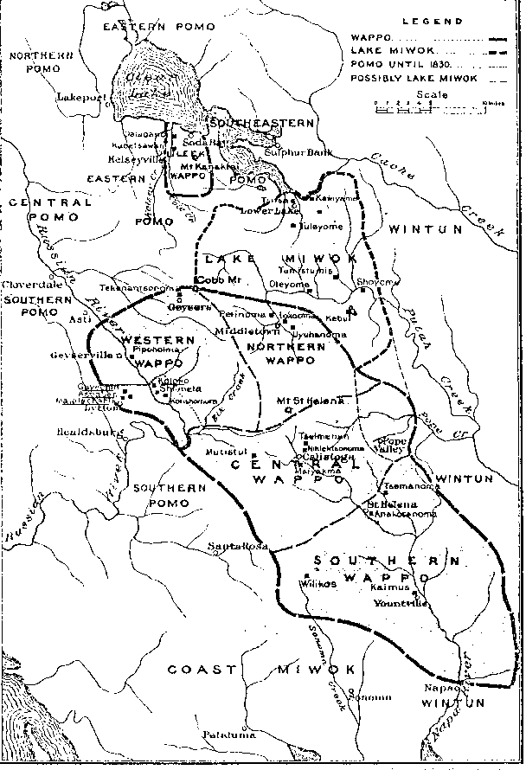
This is a map of the Napa Valley area. It shows the present day cities and rivers.Notice how the area is divided into four areas.

Wappo Indians of Napa County
Houses

The Wappos built their summer structures using a framework of branches tied together in a dome shape with a thatch covering made from leaves and smaller branches. The doors were covered at night with bundles of grass tied together. Women gathered the materials and the men did the building. When the structures became dirty they were burnt down.
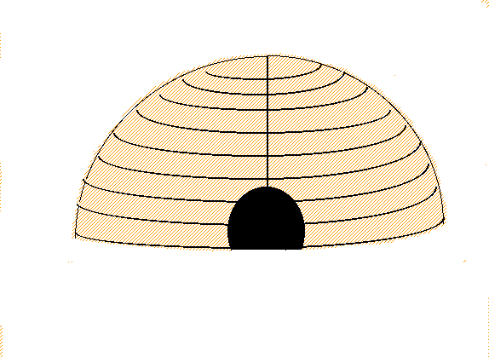

Wappo Indians of Napa County
Wappo Indians of Napa County
Clothing and Jewelry

Most of the year the Wappos did not wear clothing! When they did wear clothing, the women wore double aprons made from grasses. Men tied their long hair back.
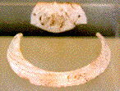
During the winter they wore capes made from animal hides.
The Wappos did wear
jewelry made from bones.

They made beads from shells they found on their journeys to the ocean,
or traded with other nearby Indian tribes.
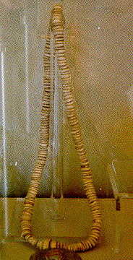
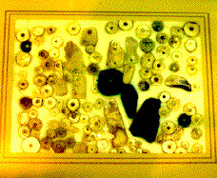
They made necklaces from the beads
strung on strings made from plant fibers.

The Wappo Tribe
Summary and Definition: The Wappo tribe were a California tribe of Native American Indians who were hunter gatherers. The Wappo tribe were located in California on the headwaters of the Napa River, and Pope and Putah Creeks, and a stretch of the Russian River. A strong, stubborn people who fought against neighboring tribes then Mexican and American encroachment of their tribal lands.

What did the Wappo tribe live in?
The Wappo tribe lived in several different types of shelters dependent on the natural resources that were available in their location. Their homes included Grass Mat Houses where there was access to reeds and rushes to make make mats. Wappo people with easy access to forest areas built shelters known as Cedar Bark Tepees. Other Wappo Native Indians built Winter Pit Houses that consisted of villages of semi-subterranean winter homes that were built up to 15 feet into the ground. The Wappo pit house was constructed with a wooden frame that was completely covered in earth.

What food did the Wappo tribe eat?
Food eaten by the Wappo was usually either roasted or stone-boiled and meals were eaten at eight or nine in the morning and again at sundown. The food that the Wappo tribe ate included their staple diet of acorns which they ground into acorn meal. The abundant species of oak trees on their lands produced seven different kinds of acorns. The acorns gathered by the Wappo tribe were stored up to one year, ground into acorn meal and leached to make soup, cakes and bread. The Wappo hunted deer (venison), elk, fowl, and small game such as rabbits and quail. Fish was also another important food source, particularly salmon. The Wappo hunter-gathers collected other foods including buckeye nuts, pepperwood nuts, various greens, roots, bulbs, and berries. Wild fruits and berries included Thimbleberry, Elderberry, California Wild Grape, Thimbleberry and Chokecherry. The bulbs of the Yellow Mariposa Lily were used for food, eaten like potatoes. Most foods were dried and stored for use during the winter months. Coastal groups of Wappo people hunted for sea mammals and considered dried seaweed a delicacy.

What clothes did the Wappo men wear?
The clothes worn by the Wappo men varied according to the season. During the summer months the men wore a breech cloth or just went naked. In the winter months warm clothing was required and their winter clothing was made from the skins of animals such as deer (buckskin), elk, squirrel, rabbit and wildcats. The Wappo winter clothes included fur robes and cloaks, shirts, wrap-around kilts, mitts and leggings that were often decorated with fringes. They wore one-piece moccasins with a front seam whilst hunting or traveling, but went barefoot in the warmer weather.

What clothes did the Wappo women wear?
The clothes worn by the Wappo women included blouses and aprons that covered the front and back made of shredded willow bark. Their dresses or skirts fell to knee or calf length and were belted and fringed. Special clothes were strung with ornaments, tassels and porcupine quills. Twined tule sandals, or moccasins, covered the feet of the Wappo women in the winter and they wore fur robes to keep warm.

Where did the Wappo tribe live?
The Wappo are people of the California Native American cultural group. The location of their tribal homelands are shown on the map in the Napa Valley region in Northern California. The geography of the region in which they lived dictated the lifestyle and culture of the Wappo tribe.
- Land: Sea, coastal regions, rivers and lakes
- Climate: Mild temperate climate
- Natural Resources: Oak trees, acorns, buckeye nuts, mushrooms, hazel nuts, bulbs, roots and grasses
- Types of housing or shelters: Types of housing or shelters: Wickiups and pit houses
- Land animals: The animals included deer, elk, chipmunks, rabbits, squirrels, quail, mountain sheep and bear
- Sea Mammals: Seals, sea lions and sea otters
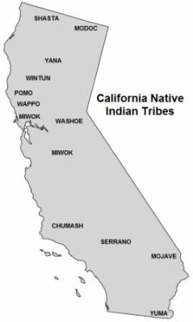
- Insects: Crickets, grasshoppers, caterpillars and dried locusts were all eaten to supplement the diet

